Fiber Optics

|  |  |  |
| --- | --- | --- |
| I |  | INTRODUCTION |

Fiber Optics, a branch of optics dealing with the transmission of light through hair-thin, transparent fibers. Light signals that enter at one end of a fiber travel through the fiber with very low loss of light, even if the fiber is curved. A basic fiber-optic system consists of a transmitting device (which generates the light signal), an optical-fiber cable (which carries the light), and a receiver (which accepts the transmitted light signal and converts it to an electrical signal).

|  |  |  |
| --- | --- | --- |
| II |  | OPERATION |

Fiber-optic transmission of light depends on preventing light from escaping from the fiber. When a beam of light encounters a boundary between two transparent substances, some of the light is normally reflected, while the rest passes into the new substance. How much of the beam is reflected, and how much enters the second substance, depends on the angle at which the light strikes the boundary. When the Sun shines down on the ocean from directly overhead, for example, much of its light penetrates the water. When the Sun is setting, however, its light strikes the surface of the water at a shallow angle, and most of it is reflected. Fiber optics makes use of certain special conditions, under which all of the light encountering the surface between two materials is reflected, to reduce loss.

A principle called total internal reflection allows optical fibers to retain the light they carry. When light passes from a dense substance into a less dense substance, there is an angle, called the critical angle, beyond which 100 percent of the light is reflected from the surface between substances. Total internal reflection occurs when light strikes the boundary between substances at an angle greater than the critical angle. An optical-fiber core is clad (coated) by a lower density glass layer. Light traveling inside the core of an optical fiber strikes the outside surface at an angle of incidence greater than the critical angle so that all the light is reflected toward the inside of the fiber without loss. As long as the fiber is not curved too sharply, light traveling inside cannot strike the outer surface at less than the critical angle. Thus, light can be transmitted over long distances by being reflected inward thousands of times with no loss (*see* Optics; Reflection).

|  |  |  |
| --- | --- | --- |
| III |  | APPLICATIONS |

The most widespread use of fiber optics is in communications. But optical fibers can carry light for illumination, to convey images, and even to transmit laser beams.

|  |  |  |
| --- | --- | --- |
| A |  | Communications |

Use of fiber optics in communications is growing. Fiber-optic communications systems have key advantages over older types of communication. They offer vastly increased bandwidths, allowing tremendous amounts of information to be carried quickly from place to place. They also allow signals to travel for long distances without repeaters, which are needed to compensate for reductions in signal strength. Fiber-optic repeaters are currently about 100 km (about 62 mi) apart, compared to about 1.5 km (about 1 mi) for electrical systems.

Many long-distance fiber-optic communications networks for both transcontinental connections and undersea fiber cables for international connections are in operation. Companies such as AT&T, MCI WorldCom, and Sprint have virtually replaced their long-distance copper lines with optical-fiber cables. Local telephone service providers use fiber-optic cables between central office switches and sometimes extend it into neighborhoods and even individual homes. Cable television companies transmit high-bandwidth TV signals to subscribers via fiber-optic cable.

Local area networks (LANs) are another growing application for fiber optics. Unlike long-distance communications, LANs connect many local computers to shared equipment such as printers and servers. LANs readily expand to accommodate additional equipment and users. Private companies also use fiber optics and its inherent security to send and receive data. Such firms and institutions as IBM, Wall Street brokerages, banks, and universities transfer computer and monetary information between buildings and around the world via optical fibers.

One of the fastest growing fiber-optic markets is transmitting information for so-called intelligent transportation systems: “smart” highways and streets with traffic lights that respond to changing traffic patterns, automated toll booths, and changeable message signs that give motorists information about delays and emergencies.

|  |  |  |
| --- | --- | --- |
| B |  | Other Applications |

The simplest application of optical fibers is the transmission of light to locations that are otherwise difficult to illuminate. Dentists’ drills, for example, often incorporate a fiber-optic cable that lights up the insides of patients’ mouths.

Optical fibers are used in some medical instruments to transmit images of the inside of the human body. Physicians use an instrument called an endoscope to view these inaccessible regions. The endoscope sends a beam of light into a body cavity, such as the inside of the stomach, via a fiber. A bundle of fibers returns a reflection of the inside of the cavity. The bundle consists of several thousand very thin fibers assembled precisely side by side and optically polished at their ends. Each individual fiber carries a tiny bit of the final image, which is reconstituted and observed through a magnifier or a television camera. Image transmission by optical fibers is also widely used in photocopiers, in phototypesetting, in computer graphics, and in other imaging applications.

Optical fibers are used in a wide variety of sensing devices, ranging from thermometers to gyroscopes. The potential in this field is nearly unlimited because transmitted light is sensitive to many environmental parameters, including pressure, sound waves, structural strain, heat, and motion. The fibers are especially useful where electrical effects make ordinary sensors or wiring useless, less accurate, or even hazardous. Fibers have also been developed to carry high-power laser beams for cutting and drilling. Fiber-optic lasers are sometimes used for surgery.

|  |  |  |
| --- | --- | --- |
| IV |  | HISTORY AND CURRENT RESEARCH |

In the early 1950s, Abraham van Heel of the Delft University of Technology in The Netherlands introduced cladding as a way to reduce light loss in glass fibers. He coated his fibers with plastic. Even with cladding, however, light signals in glass fibers would fade after traveling only a few meters. In 1967 electrical engineers Charles Kao and George Hockham of Britain’s Standard Telecommunications Labs speculated that these high losses were due to impurities in the glass. They were correct: Impurities within the fibers absorbed and scattered light. Within two decades, engineers solved the impurity problem. Today, silica glass fibers of sufficient purity to carry infrared light signals for 100 km (62 mi) or more without repeater amplification are available.

The development of new optical techniques will expand the capability of fiber-optic systems. Newly developed optical fiber amplifiers, for example, can directly amplify optical signals without first converting them to an electrical signal, speeding up transmission and lowering power requirements. Dense wave division multiplexing (DWDM), another new fiber-optic technique, puts many colors of light into a single strand of fiber-optic cable. Each color carries a separate data stream. Using DWDM, a single strand of fiber-optic cable can carry up to 3 trillion bits of information per second. At that rate, downloading the entire contents of the Library of Congress, a feat requiring 82 years with a dial-up modem, would take just 48 seconds.

Reviewed By:  
April Holladay

**Microsoft ® Encarta ® Encyclopedia 2004.** © 1993-2003 Microsoft Corporation. All rights reserved.

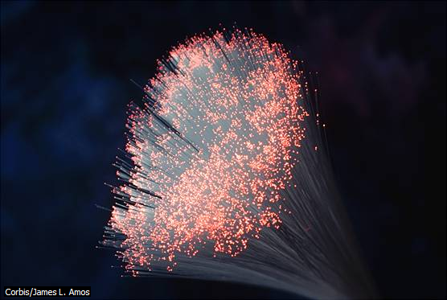

Fiber Optic Strands A strand of fiber optic cable reflects the light that passes through it back into the fiber, so light cannot escape the strand. Fiber optic cables carry more information, suffer less interference, and require fewer signal repeaters over long distances than wires.

© 1993-2003 Microsoft Corporation. All rights reserved.

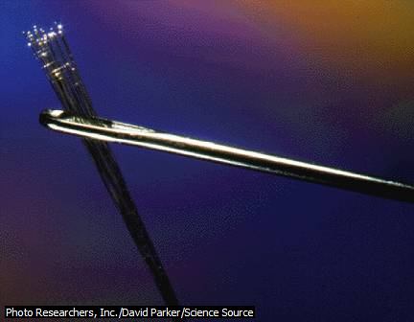

Fiber-Optic Cable Fiber-optic cables provide an alternative to bulky copper-wire cables in the telecommunications industry. A single pair of light-transmitting optical cables can carry over a thousand conversations simultaneously. Several individual optical cables easily pass through the eye of this needle.

© 1993-2003 Microsoft Corporation. All rights reserved.